Supported by: | 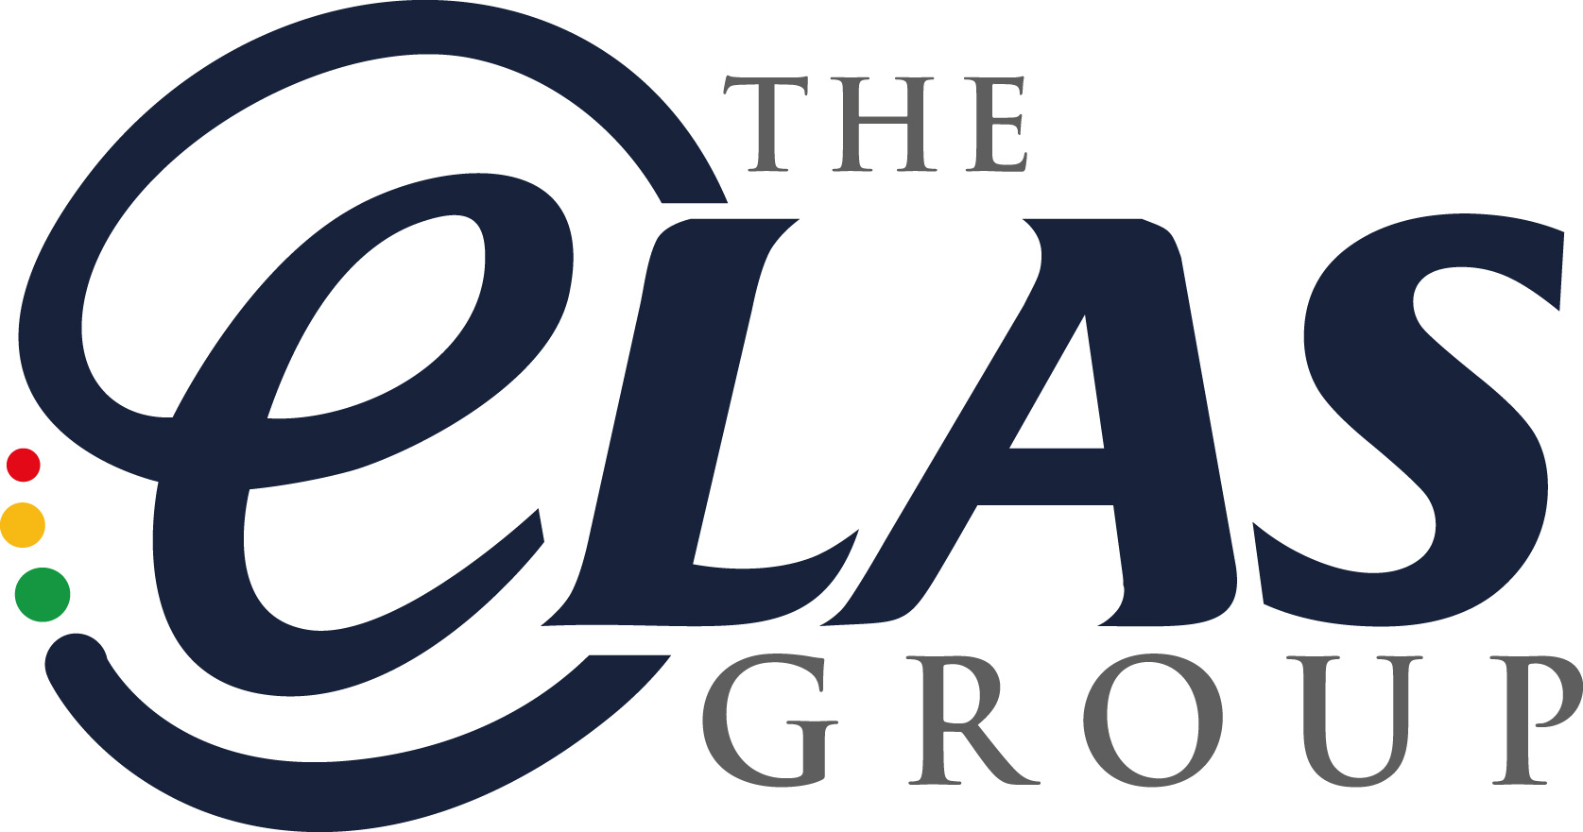

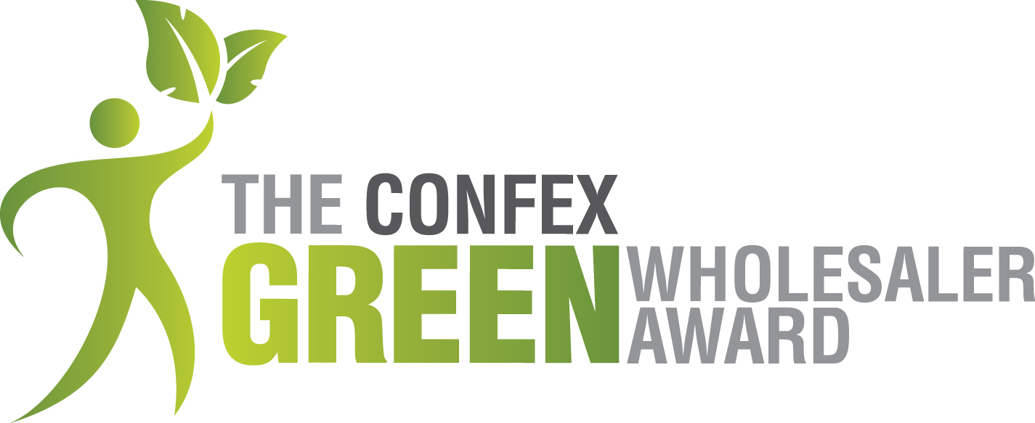

2017

Is your business making changes to reduce waste, increase efficiencies to help reduce environmental impact and cut costs? If so, then enter the Confex Green Wholesaler Awards 2017 and achieve recognition.

- PROMOTE YOUR COMPANY AS SUSTAINABLY EFFICIENT
- GAIN COMPETITIVE EDGE
- BOOST BUSINESS OPPORTUNITIES
- SAVE MONEY AND STOP WASTE

Complete this simple questionnaire to help us identify the most environmentally friendly Confex Wholesalers in 2017 and promote the sharing of Best Practice. Tell us what you are doing to tackle the 6 main areas that can make your business more sustainable (Energy, Waste Management, Social, Ethical, Transport and Environment). Please attach any supporting documents/images that you feel are relevant to your application.

Completed applications must be returned to us no late than 31st January 2017.

Each company that submits a fully completed entry form will
receive a £50 Love to Shop Voucher

All information will be strictly confidential unless consent is given for it to be shared.
CONTACT DETAILS
- Name of business: ………………………………………………………………………..………………………………………

………………………………………………………………………………………………………………….

- Your name and position: …………………..……………………………………………..........……

……………………………………….…………………………………………………………………………

- Please state company turnover for tax year April 2015 – April 2016 …………………….…

- a) Phone no: …………………………………… b) Email: …........................................................

- Award category entered - please select ONE of the following:

  - Foodservice Wholesaler ___

  - Retail Wholesaler ___

- ENERGY

What is your business doing to improve energy efficiency in your offices, and warehouses?

Please give details as appropriate
Details
Lighting:
- Energy-saving light bulbs
- motion sensors/timers
- use of natural light
- low-hanging lighting
Heating and Refrigeration:
- Use of low Global Warming Potential (GWP) refrigerants
- use of timers
- improved insulation
- refrigeration kept at optimum temps
- use of eutectic plates as an alternative to chiller vans
Alternative Energy Sources:
- Solar panels
- wind turbines
- biomass
- ground/air source heat pumps,
- use of green suppliers/green tariffs
Water usage:
- Use of water efficient products
- Regular servicing of water using appliances and water pipes etc.
Other:
- Making staff aware of energy efficiencies

Please list any other energy saving measures employed by your business that are not covered above

Please detail any future improvement plans:

2. WASTE MANAGEMENT

What is your business doing to improve waste management in the workplace?

Please give details as appropriate
Details
Waste reduction measures:
- Printing double-sided, reduced paper use, unused equipment donated to charities, damaged items sold at discounted prices
Re-using procedure:
- Backhauling of cardboard boxes, return schemes for pallets, glass/tin containers, repair items, effective maintenance
Recycling:
- Separation of waste in warehouse and office for recycling, effective storage of waste to be recycled
Other:
- Making staff aware of waste management policy

Please list any other recycling or prevention of waste by your business not covered above

Please detail any future improvement plans.

3. TRANSPORT

What is your business doing to reduce environmental impact in terms of transport and travel?

Please give details as appropriate
Details
Delivery vehicles:
- Use of energy efficient vehicles; fuel efficiency, aerodynamic design, regular servicing, low tyre-resistance
- Use of biofuel or other sustainable fuel
Delivery procedures:
- Effective vehicle packing
- Route efficiency
- Back-hauling products
- Assessment of fuel consumption
Business Travel:
- Reduced travel
- greater use of e-mail, video meetings, phone calls
- Use of public transport,
- Use of energy efficient vehicles
Employee Commutes:
- Lift shares
- Ride to work schemes,
- Employ locally,
- Working from home
Other:
Please list any other transport efficiency measures employed by your business not covered above

Please detail any future improvement plans.

4. SOCIAL AND ETHICAL PERFORMANCE

Tell us how your business is positively involved in the local community and takes ethical issues into consideration relating to products and suppliers.

Please give details as appropriate
Details
Products and Suppliers:
- Stock and promotion of fair-trade goods, organic/locally sourced products, ethical assessment of suppliers
Charitable Donations:
- Donation of items close to expire to local organisations such as food banks, homeless centres
Community Involvement:
- Supporting/sponsoring local events/clubs/projects
Other:
Please list any other activities related to social and ethical performance

Please detail any future improvement plans.

5. ENVIRONMENTAL REGULATIONS, POLICY AND PERSONNEL

Please complete the table below by describing your business’s status for each environmental regulation listed, giving explanations on why these are applicable to your business, if you comply and how you are dealing with them.

For more information on these categories, visit on our website: http://www.confex.ltd.uk/green_wholesaler_award.asp

Environmental Issue | Applicable to your Business |  | Please explain why these regulations are applicable to your business | Compliant
Packaging Regulations | Yes | No
Waste Disposal | Yes | No
Other (please specify)  e.g. Transport, Air/Noise/Light Pollution | Yes | No

Tell us how you implement green strategies in your business
Please give details as appropriate:-
Details…
Environmental/Green policy
Official policy or strategy regularly reviewed
Environmental Co-ordinator
Person responsible for environmental impact assessment
Environmental Targets
Any specific targets and systems set up to monitor them, public disclosure of analysis

Please detail any future improvement plans.

- FINANCIAL IMPLICATIONS

Tell us the main areas where your business has saved money by adopting sustainable practices.

Tell us how you have, or plan to invest money in implementing sustainable practices.

I certify that all of the information provided is an accurate and fair representation of my business, and I would like to be considered for a Confex Green Wholesaler of the Year Award 2017.

Signed: ……………………………… Print full name: …………….…………………….…………

Date: …………………………

Please return completed questionnaires to:-
Gilly Hunt, Confex Ltd, Cotswold Business Village, London Road, Moreton-in-Marsh, Glos GL56 0JQ
or email it to:- tomgittins@confex.ltd.uk

FINAL DEADLINE FOR ENTRIES: 31st JANUARY 2017

Applicants to be shortlisted and then the finalists will be judged by an independent environmental consultant from the renewable energy industry.

Thank you for completing the Confex Green Wholesaler Award questionnaire for 2017. We hope that this exercise has helped you to focus on the environmental impact of your business and may have prompted ideas for improvements that could be introduced in the future.

